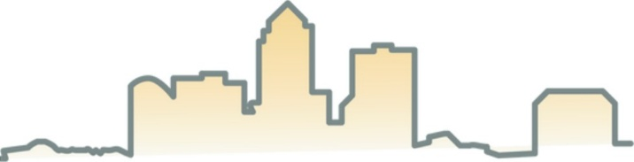

Evelyn K Davis Center

FOR WORKING FAMILIES

**SAVE THE DATE!**  
CAREER FAIR  
**September 22nd  
10:00 AM to 2:00 PM**  
DMACC Urban Campus, Building 7  
1144 7th Street, Des Moines 50314



**Meet with a career coach for a resume!**

**Join us for our Fall Career Fair!**

**Employers from all over the metro are hiring so stop by on September 22nd.**

**Resumes are recommended**



Questions? 515-697-7700 or email info@evelynkdaviscenter.org